

# AL and ML Capstone Project

Capstone Project Weekly Progress Report

|  |  |
| --- | --- |
| **Semester** | Fall-2024 Semester 3rd |
| **Course Code** | AML-3406 |
| **Section** | Section 1 |
| **Project Title** | Car Damage Detection |
| **Group Name** | Group B |
| **Student names/Student IDs** | Sakshi (C0908000) Bansil Patel (C0912873)  Harsh Mohile (C0912872) Meet Patel (C0910378)  Rachit Bhatt (C0902810) |
| **Reporting Week** | Week 5 |
| **Faculty Supervisor** | William Pourmajidi |

1. **Grade the level of collaboration from different aspects between team members: (use: good, medium, below expectation)**

|  |  |  |  |  |
| --- | --- | --- | --- | --- |
| **Sakshi** | **Bansil Patel** | **Harsh Mohile** | **Meet Patel** | **Rachit Bhatt** |
| **Good** | **Good** | **Good** | **Good** | **Good** |

# AL and ML Capstone Project

1. **Tasks outlined in the previous Weekly Progress Report for this reporting week at the individual level and group level**
   1. **Individual tasks (each team member) Sakshi:** Researched for CI/CD Pipeline for Mlops.

**Bansil Patel & Meet Patel:** Model Selection and experimentation.

**Harsh Mohile & Rachit Bhatt:** Research on Docker for Deployment + Version control and Augmentation

* 1. **Your team’s tasks**
     + Concentrated on data preprocessing and augmentation for our car damage detection project.
     + Conducted thorough research on CI/CD pipelines to optimize our development workflow and improve deployment processes.
     + Investigated the use of Docker for deployment, evaluating its benefits for containerization and scalability.
     + Focused on selecting the most suitable algorithms to meet our project goals effectively.
     + Strengthened our workflow by establishing a version control system to enhance collaboration and project management.
     + These efforts play a crucial role in driving our project forward.

1. **Progress made in Reporting Week at an individual level and group level**
   1. **Individual progress**

**Sakshi:** Gained knowledge about CI/Cd pipeline.

**Bansil Patel & Meet Patel:** Evaluated some models on the dataset.

**Harsh Mohile & Rachit Bhatt:** Contributed for Github Management and completed Data Preprocessing.

* 1. **Your team’s progress**
     + Enhanced the quality of the dataset through thorough cleaning and transformation processes.
     + Implemented various augmentation techniques to increase dataset diversity and strengthen model robustness.
     + Evaluated and selected the most suitable algorithms and learned about CI/Cd pipeline to align with our project goals, ensuring peak performance.
     + Established an efficient version control system to facilitate collaboration and keep our workflow organized.
     + Gained knowledge about docker for deployment.

1. **The areas/tasks you could not make progress and/or complete as scheduled or the difficulties encountered in this reporting week at individual level and group level.**
   1. **Individual project blockers**

**Sakshi:** N/A

Harsh Mohile: N/A

Rachit Bhatt: N/A

**Bansil Patel & Meet Patel:** Experimenting different models.

* 1. **Your team’s project blockers**
     + Overall, the difficult part in this week was model selection. However, we handled it nicely.



# AL and ML Capstone Project

1. **Tasks to be completed in next week at individual level and group level**
   1. **Individual tasks**

**Sakshi:** Visualization and documentation.

**Bansil Patel & Meet Patel:** Applying Feature Engineering to enhance model’s learning ability.

**Harsh Mohile & Rachit Bhatt:** Train the selected models and record their performance metrics.

* 1. **Your team’s tasks**
     + Identify various features that could help in detecting car damage.
     + Feature Engineering to enhance model’s learning ability.
     + Model Training and Compare the results of different models for effectiveness.

1. **Include the tasks from your sprint planning (Github/Zenhub) for the present period.**

**Figure 1:** Status Chart of GitHub Issues in Milestone



# AL and ML Capstone Project

1. **Include charts/graphs (e.g., burn down charts) from your project management tool (Github/Zenhub) that shows your progress for the period of this report.**

**Figure 2:** Contributors in the Week



# AL and ML Capstone Project

1. **Include a note and address to your project Github with list of codes uploaded/updated on Github in this reporting week.**

[**GitHub**](https://www.github.com/rachit-bhatt/Capstone-Project)**:** <https://www.github.com/rachit-bhatt/Capstone-Project>

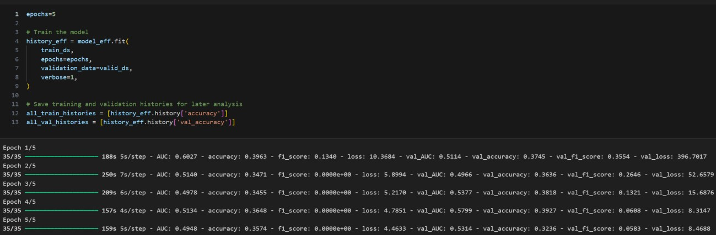

**Figure 3:** Applying NN on a Sample Dataset

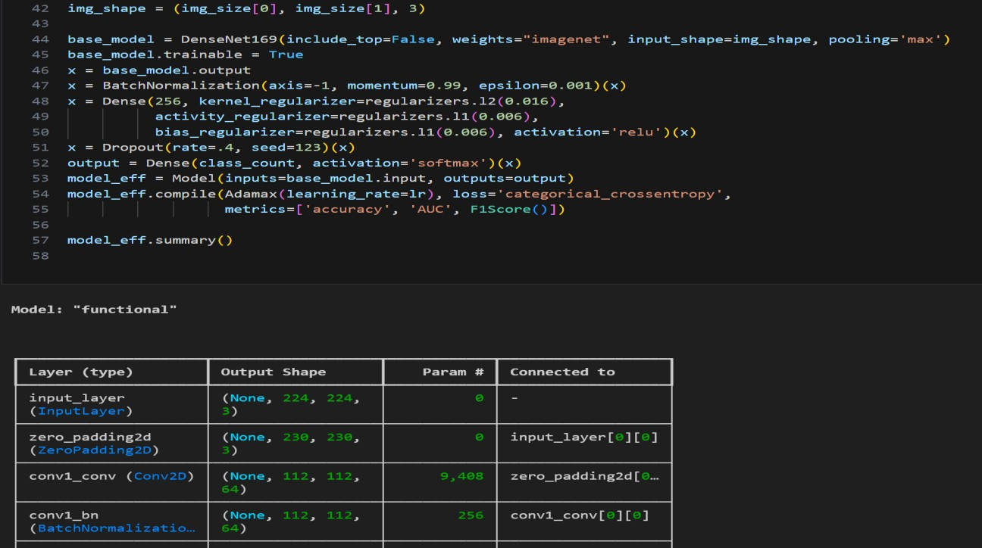

**Figure 4:** Model Evaluation Summary



# AL and ML Capstone Project

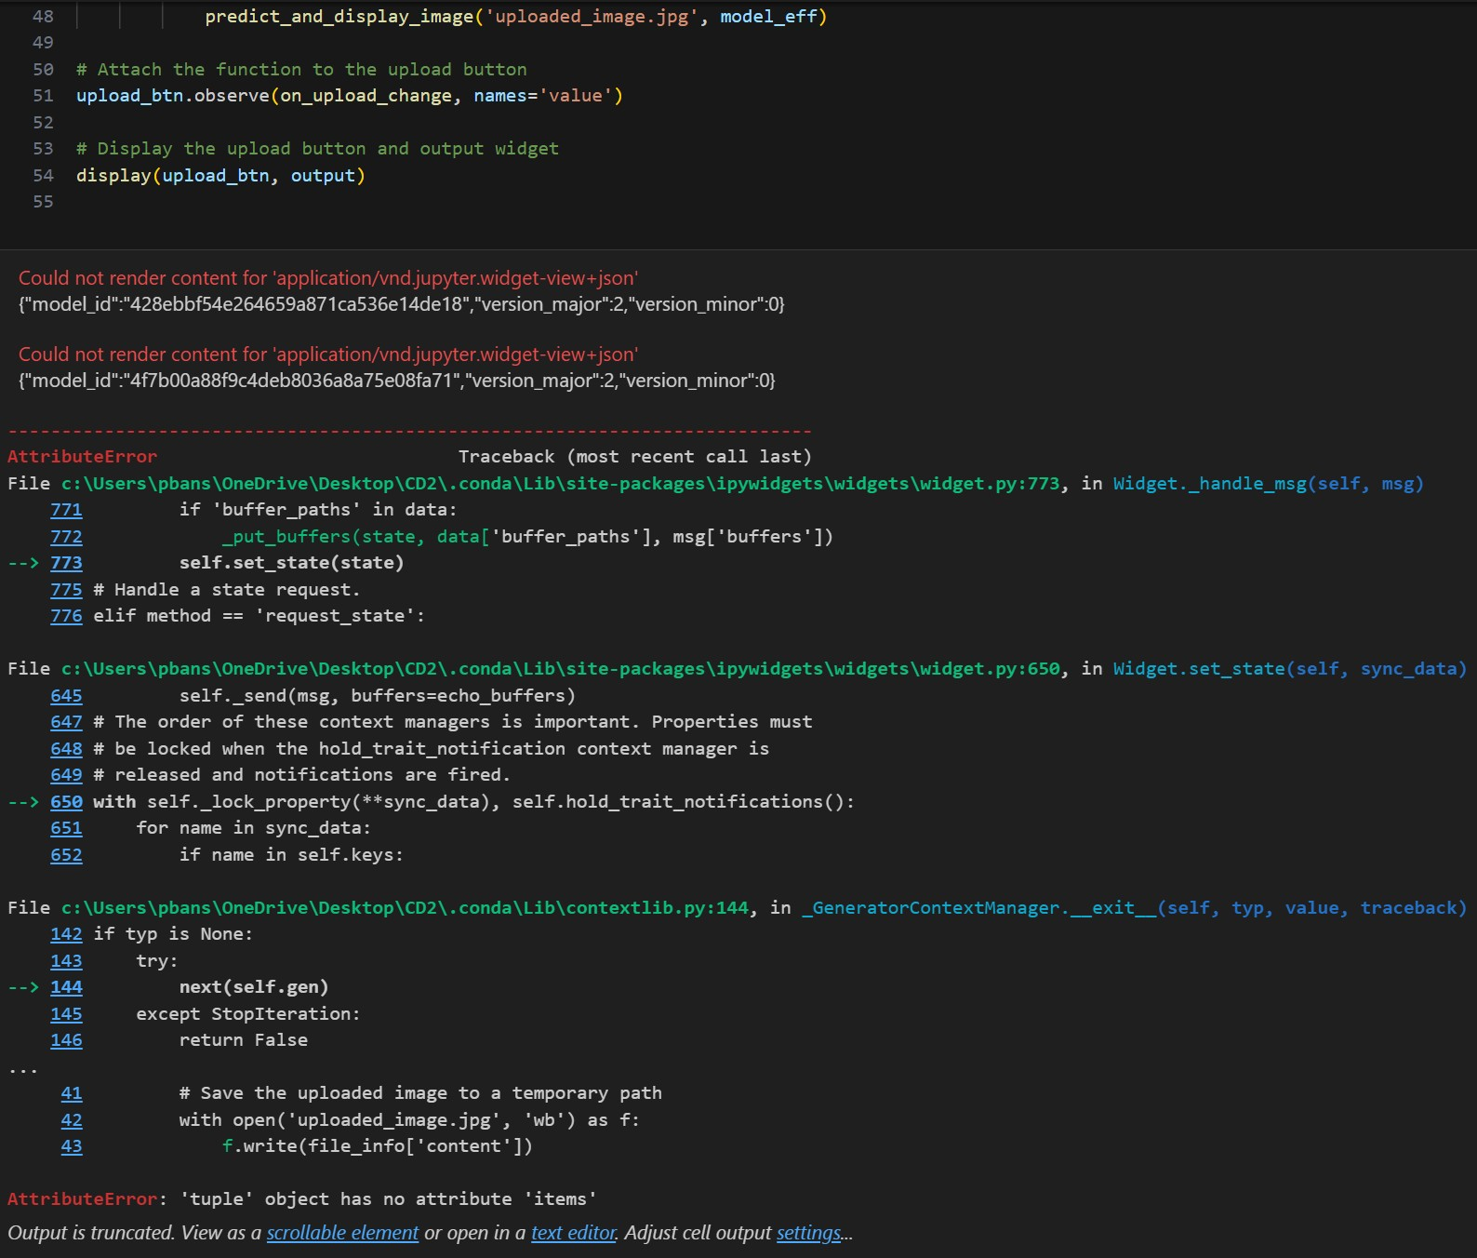

**Figure 5:** Exception – Progress Blocker